CLONING PROJECT IN LOCAL REPOSITORY USING ECLIPSE
Pre-Requisite: Before cloning project from Gitlab Make sure that the branch has been created separately for yours and the project code from master is present in your branch.
GIT LAB URL: https://git.benefitalign.com/benefitalign/employerengage/qa-automation
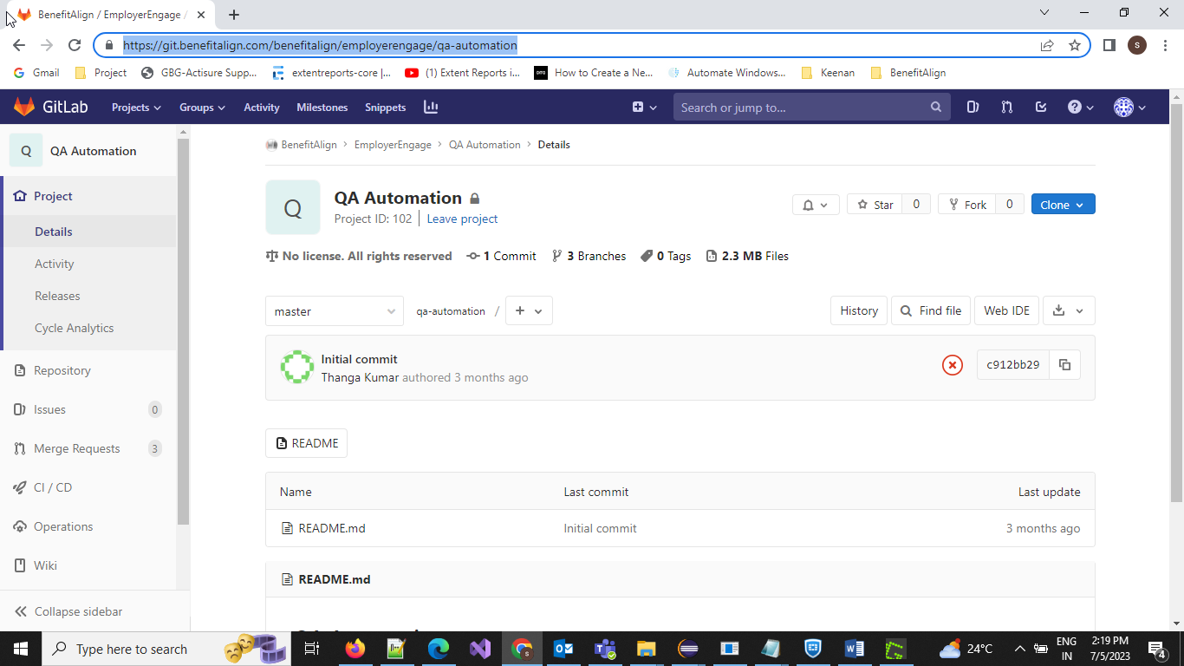
Step 1: Open Eclipse IDE Select Windows from Menu bar Chose Show view Select Other Option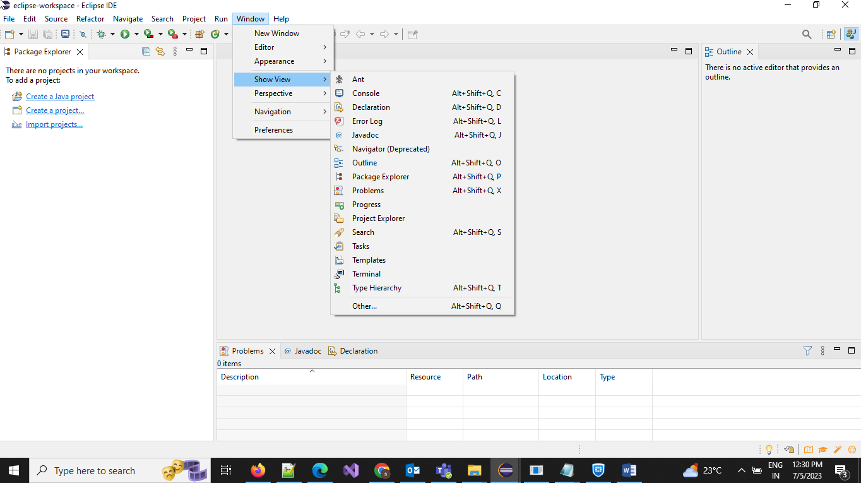
Step 2: Make sure that we are selecting Git staging and Git Repository and Click on Open. This will result in Git Staging and Git Repository to be open in Footer of Eclipse IDE

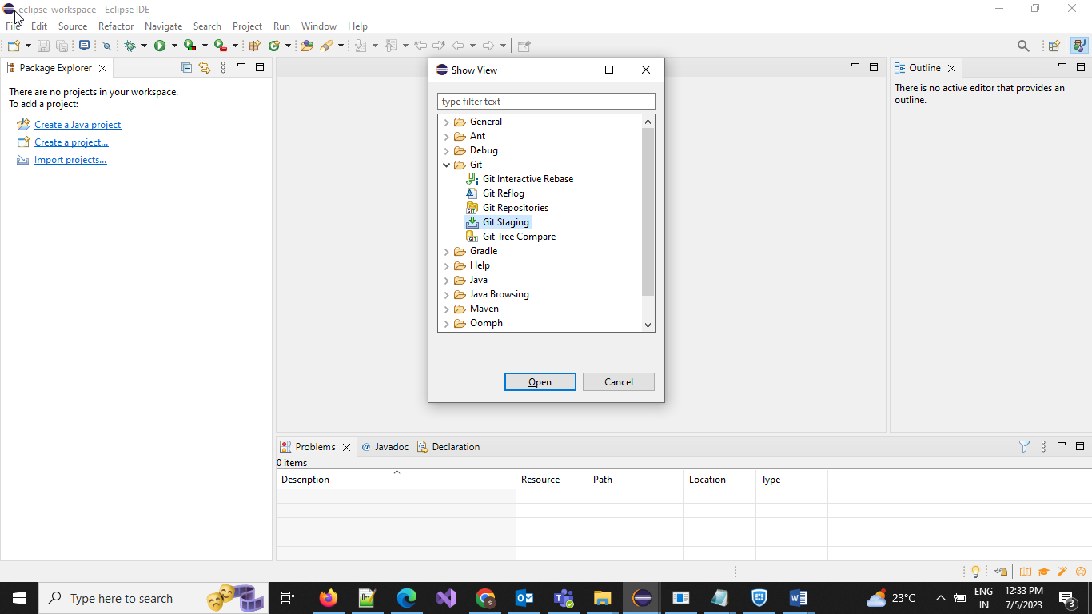
Step 3: Click on Clone a Git Repository

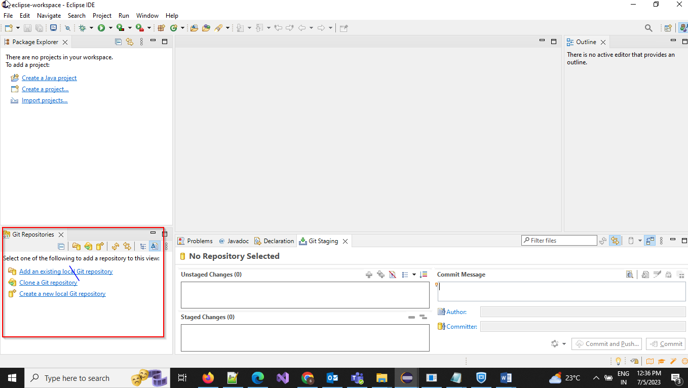

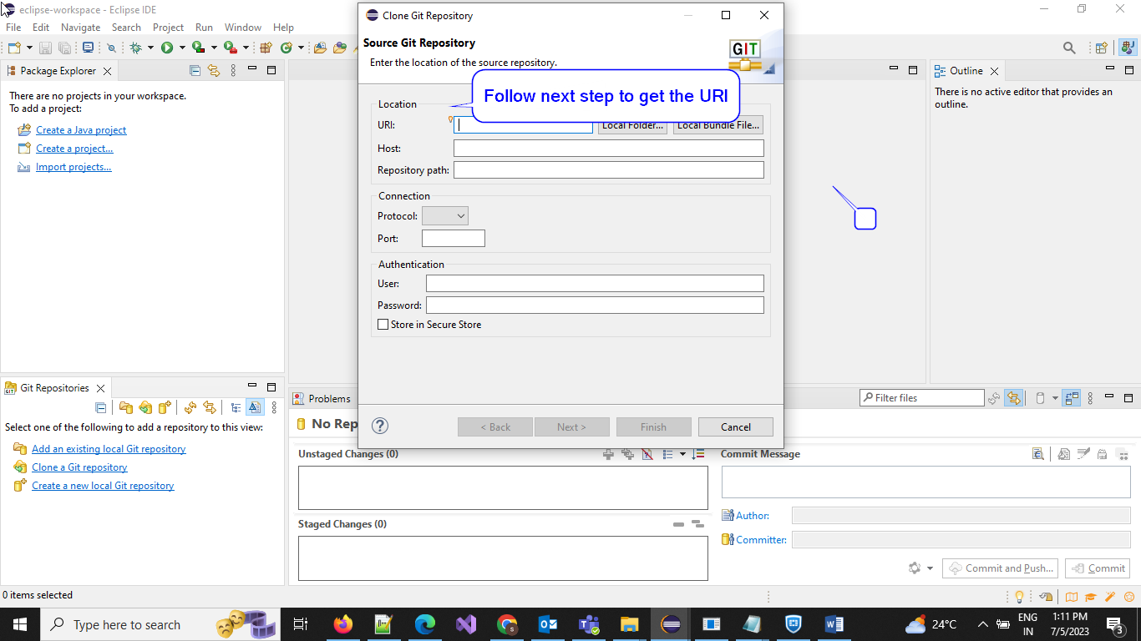
Step 4: Take the URL from Git Lab by clicking on copy icon to paste on Eclipse for cloning the project
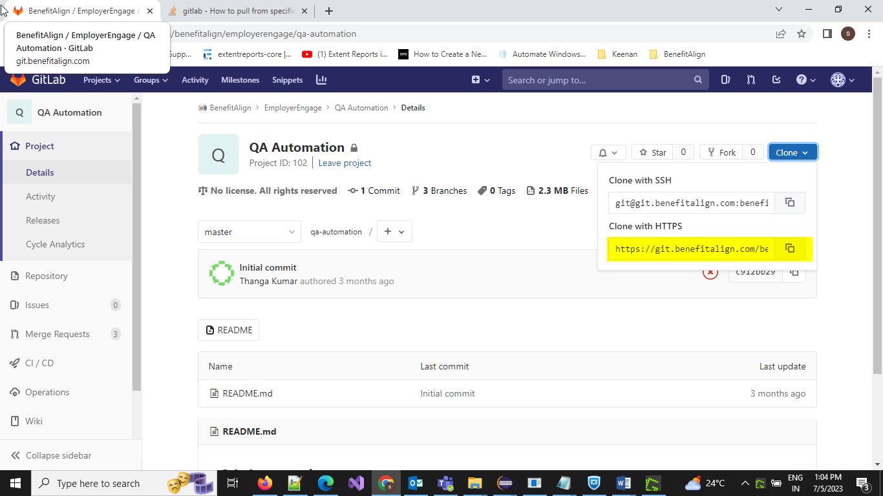

Step 5: Provide Gitlab credentials and click on Next
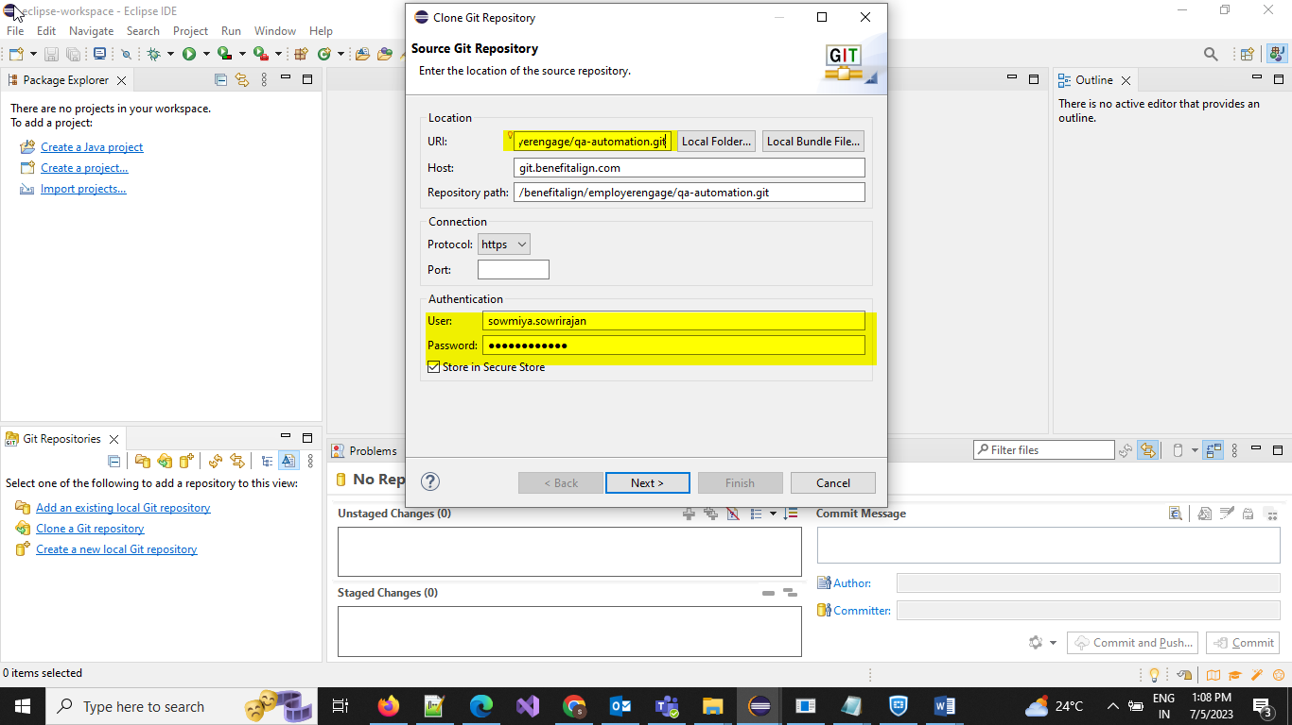

Step 6: Click on Next and select the branch in your name and click on Next
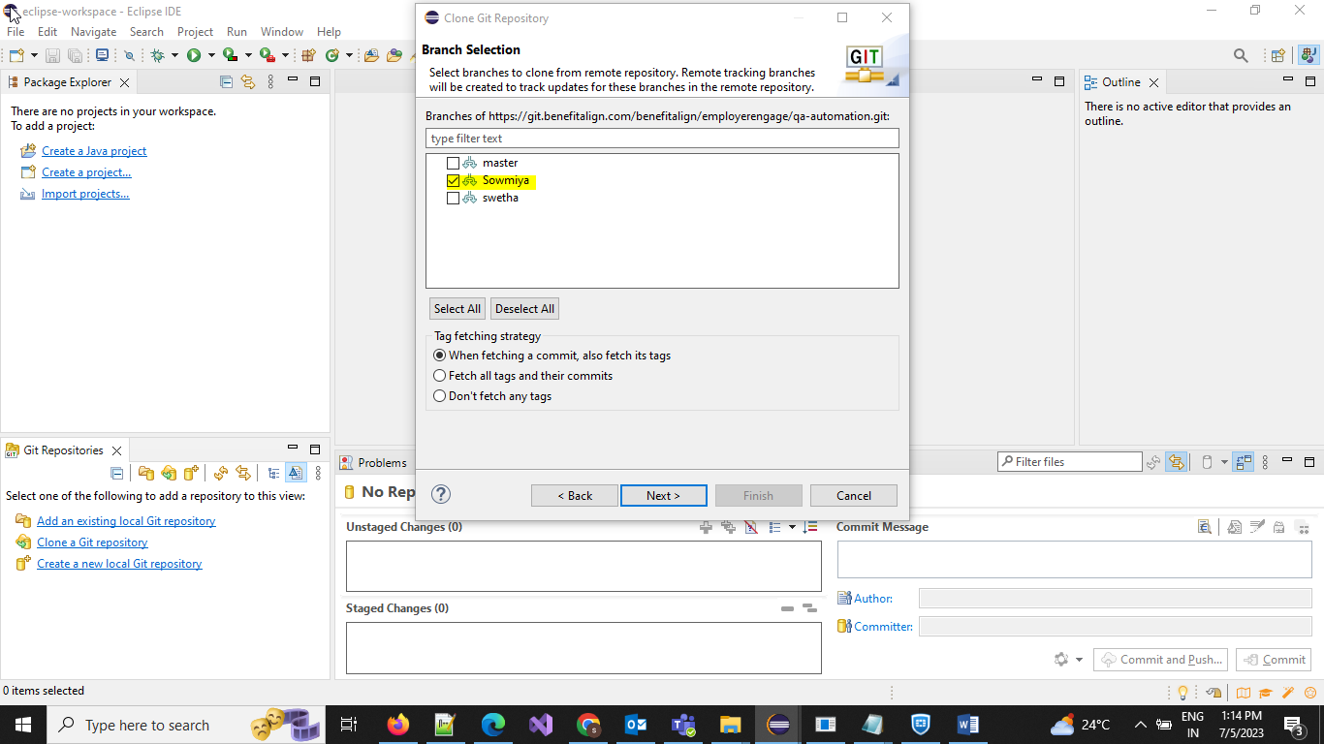

Step 7: Select the destination folder and click on Open and then Save and then click on finish
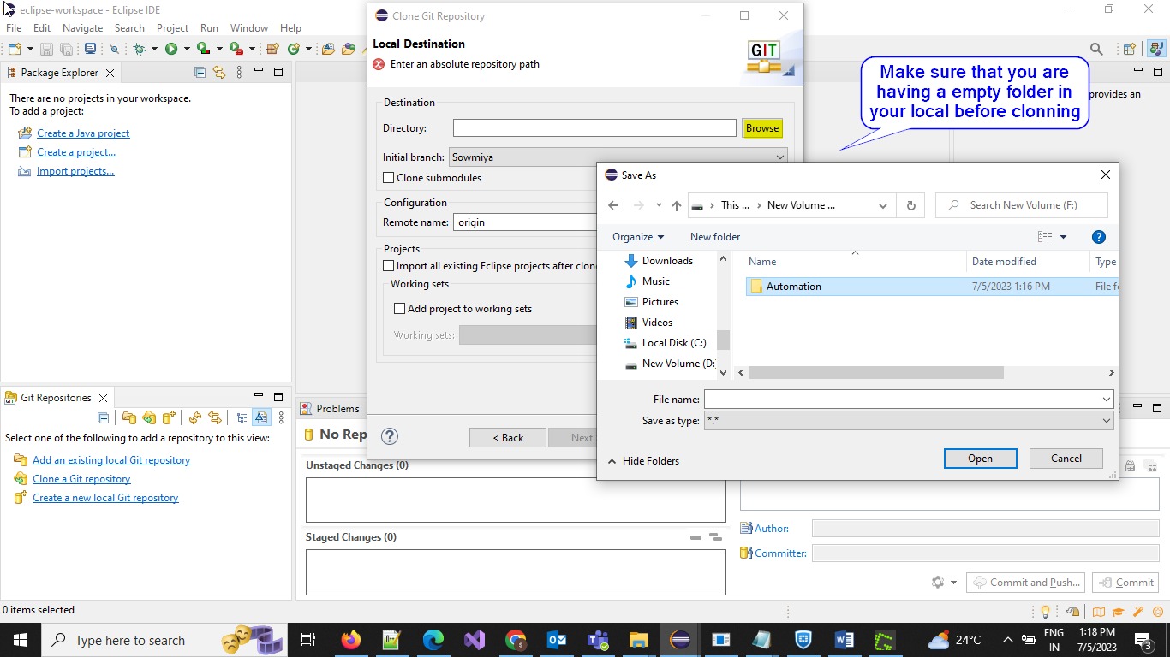

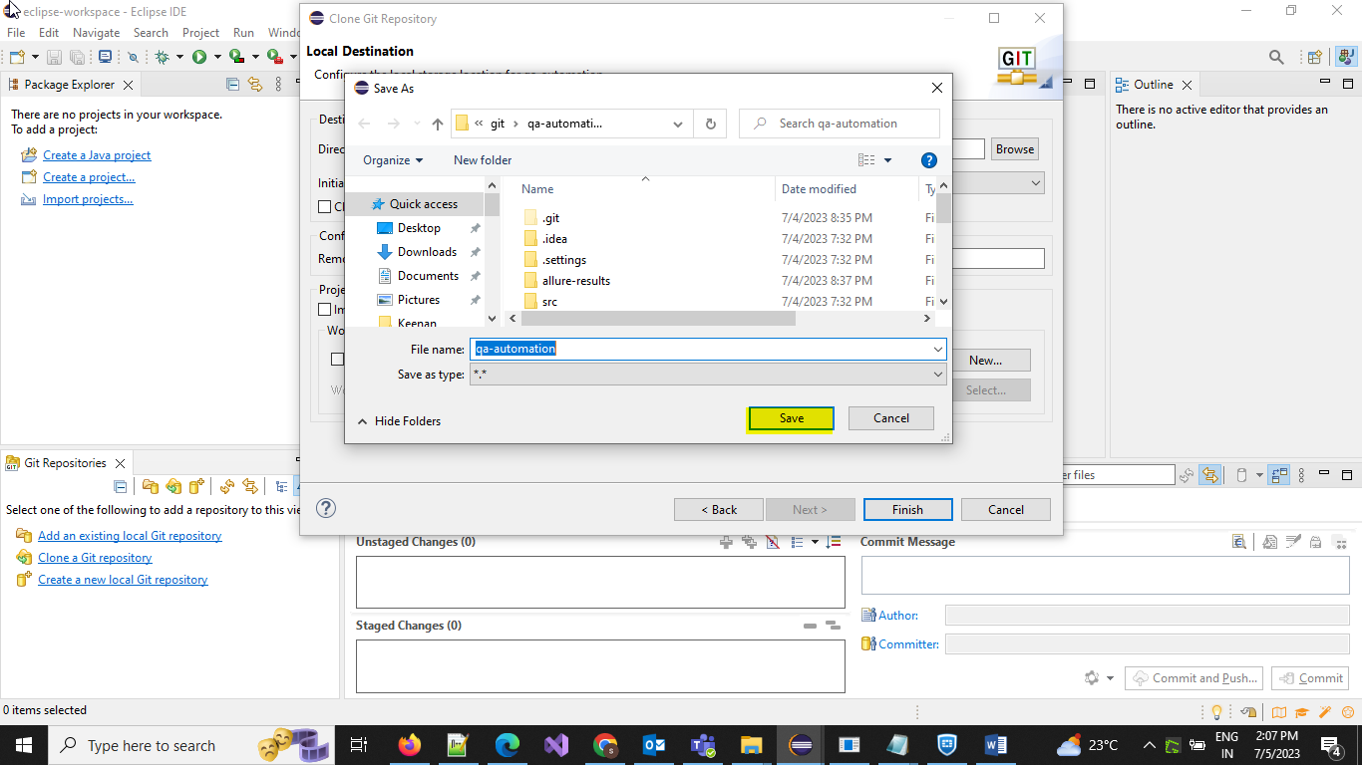

Step 8: After Clicking on finish Project will come under Git Repositories, Right click on the project and select Import Project from the tray.
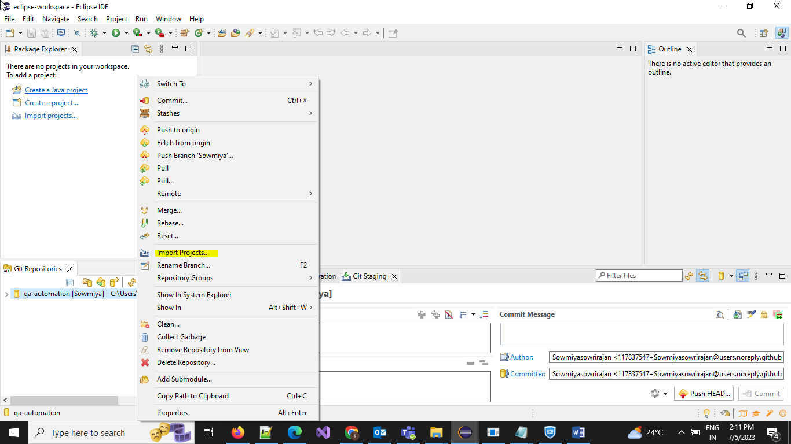

Step 9: Click on Finish to complete the Setup
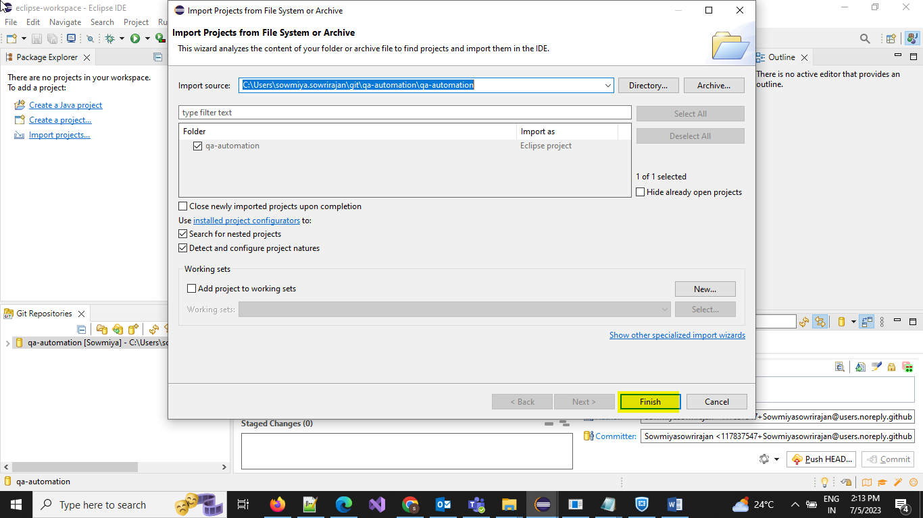

Project will get imported successfully to your Local from Gitlab and you will be able to see the project under Package Explorer
